NAIROBI (AFP) - A baby hippopotamus that survived the tsunami waves on the Kenyan coast has formed a strong bond with a giant male century-old tortoise, in an animal facility in the port city of Mombassa , officials said.
The hippopotamus, nicknamed ! Owen and weighing about 300 kilograms (650 pounds), was swept down Sabaki River into the Indian Ocean , then forced back to shore when tsunami waves struck the Kenyan coast on December 26, before wildlife rangers rescued him.
"It is incredible. A-less-than-a-year-old hippo has adopted a male tortoise, about a century old, and the tortoise seems to be very happy with being a 'mother'," ecologist Paula Kahumbu, who is in charge of Lafarge Park , told AFP.
"After it was swept and lost its mother, the hippo was traumatized. It had to look for something to be a surrogate mother. Fortunately, it landed on the tortoise and established a strong bond. They swim, eat and sleep together," the ecologist added.
"The hippo follows the tortoise exactly the way it follows its mother. If somebody approaches the tortoise, the hippo becomes aggressive, as if protecting its biological mother," Kahumbu added.
"The hippo is a young baby, he was left at a very tender! age and by nature, hippos are social animals that like to stay with t heir mothers for four years," he explained.

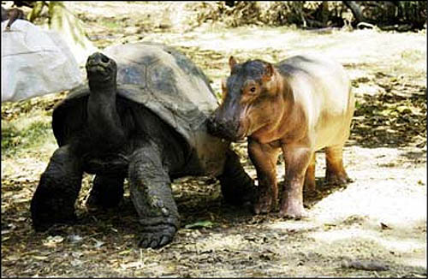

Aggressive young orphaned elephants are reported to have killed 36 rhinos, including rare black ones, in a game park in eastern South Africa.
According to conservationists, the young elephants have been provoking confrontations with the rhinos since they were introduced to Hluhluwe-Umofolozi Park in KwaZulu-Natal.The elephants were orphaned when their parents were culled in the early 1990s in an effort to control the elephant population in Kruger National Park. As they have matured, so they have become more aggressive.Attacks on rhinos have been growing over the past two years, with 13 killed, including two black rhino, in the last five months of 1999, South African newspapers report.
Spate of killings
A park ranger said he had witnessed an elephant knocking a rhino over, trampling it and driving a tusk through its chest.Conservation vet Dave Cooper said: "There was a spate of killings, and it was as if they were purposeful. The rhinos were ripped to pieces." He said that elephant and rhino routinely clash in nature "but this sort of behaviour, when elephant actively go out and chase rhino, is totally abnormal".
Fellow conservationist Tony Conway said similarly aggressive behaviour had also been seen in Pilanesberg National Park in Northwest Province - another home for the Kruger Park orphaned elephants. However, the killings at Pilanesberg stopped when six adult elephant bulls were introduced to the park. The young ones' behaviour patterns returned to normal under their influence. Officials at Hluhluwe-Umfolozi Park have asked Kruger Park to send it 10 adult bulls in the hope that their presence will have the same effect on the young elephants there. The park's top attractions are its rhino - both the white or square-lipped rhino and the rarer black or hooked-lipped rhino. There are only about 1,000 black rhino left in South Africa. 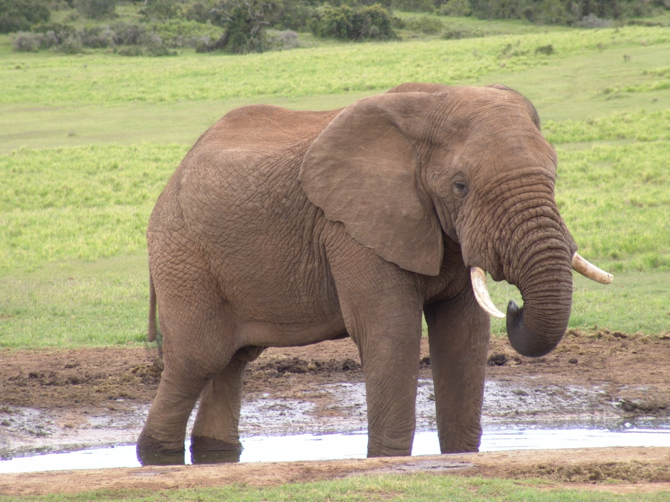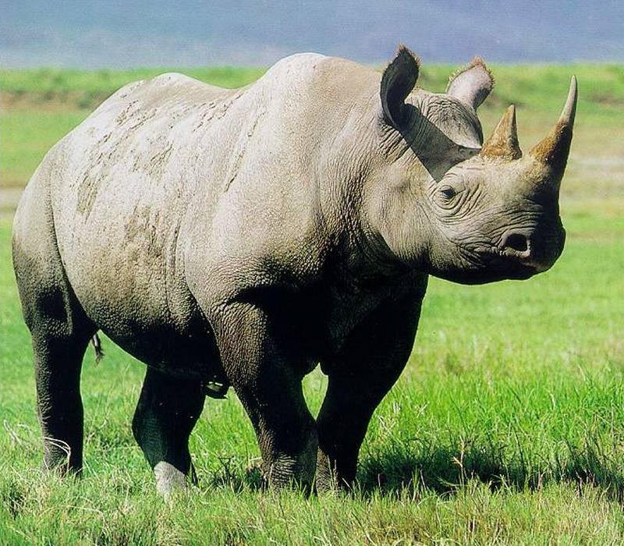
Daniel Olin was 11 years old when his parents moved to Edmonton in Canada. He liked his new school and made friends there, but then things at home started to change. His mum and dad began to argue and the arguments got worse and worse until one day, Daniel's mum left. With his father working long hours, Daniel felt very alone and very unhappy. He wanted to escape, to run away. And that's what he did.
Very early one bitterly cold morning when the snow was deep on the ground, he packed a bag with some clothes, his Walkman, some chocolate and a map of Canada and set off. He ran and ran until he could hardly breathe. His feet were heavy with the snow but he staggered on through deep snowdrifts, not even watching where he was going.
Then, disaster struck. A rock hidden by the deep snow caught his ankle and Daniel fell to the ground, crying in pain. He had broken the bone. And no one knew where he was to help him. He was bitterly cold and was starting to feel tired, but he knew that if he fell asleep in the snow, he would almost certainly die from the cold.
A spruce tree stirred ahead. From within the branches, a pair of yellow eyes watched Daniel. The puma had been stalking him. A puma is a powerful cat with claws that could shred Daniel into strips. But instead of moving in for the kill, the puma approached Daniel and lay across his chest and limbs. Daniel was too frightened to move, but soon the warmth of the animal reached Daniel and he began to feel better. From time to time, the puma pressed his muzzle against Daniel and rocked his head gently. Clearly, the puma knew that Daniel must not fall asleep. This animal should have been a real danger to Daniel and yet the boy began to feel safe.
They remained like that for several hours until Daniel and the puma heard voices. The rescue team had found them.
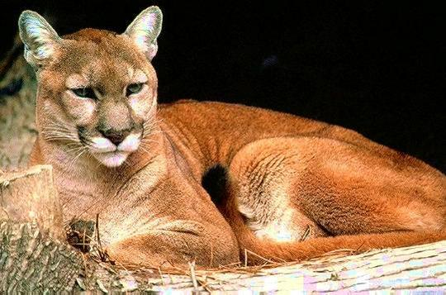

A new detective is on the beat in central Russia - Rusik the cat, the latest weapon in the battle against fish thieves. A year ago he walked into the police station as a stray kitten, but now he helps police by sniffing out illegal cargoes of fish.
The fish that Rusik sniffs out are sturgeon. Sturgeon are killed by fishermen, who sell their eggs as expensive 'caviar'. But sturgeon are facing extinction and it is illegal to catch them, so Rusik is on the case. The police say that no matter how well the smugglers hide the fish, Rusik is always able to point his nose in the right direction and find them.

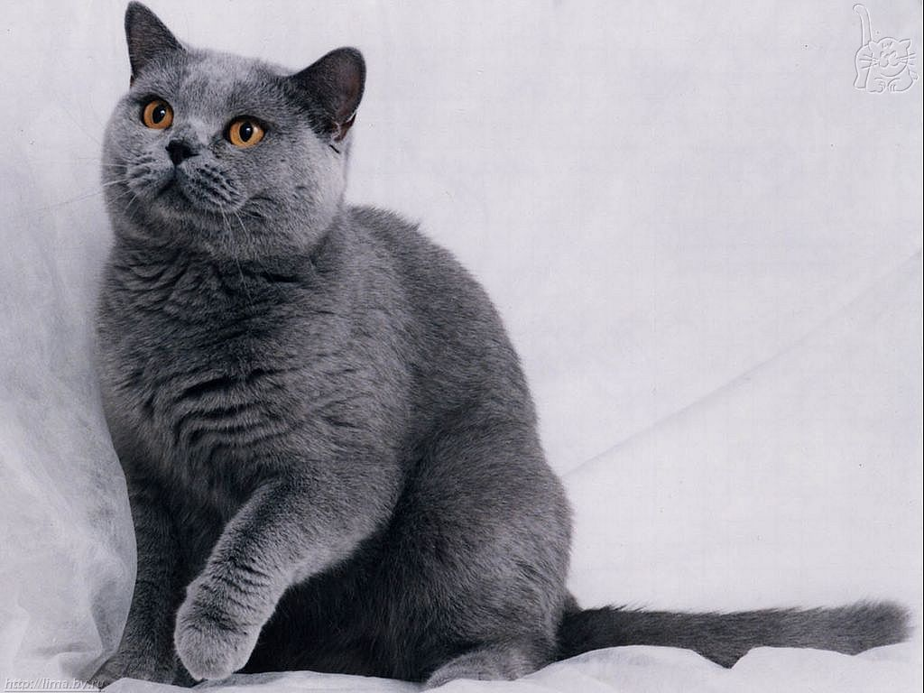

In 1989, an Australian teenager, Adam, and his two friends were surfing in the Pacific Ocean with a school of dolphins. They were all enjoying themselves until suddenly the dolphins started zooming around and under the boys, then surfacing and splashing violently. Something was wrong and the boys were worried.
Just then, Adam saw a fin coming toward him, but it wasn’t a dolphin; it was a tiger shark! The shark attacked, taking a huge chunk out of Adam’s surfboard and knocking him into the water. Adam was wounded. The shark saw Adam in the water, turned and attacked again. The dolphins went after the shark, and, worked together to chase him away. Adam’s human friends helped him to shore. He had cuts on his hip, thigh, and stomach. But thanks to the dolphins, Adam lived
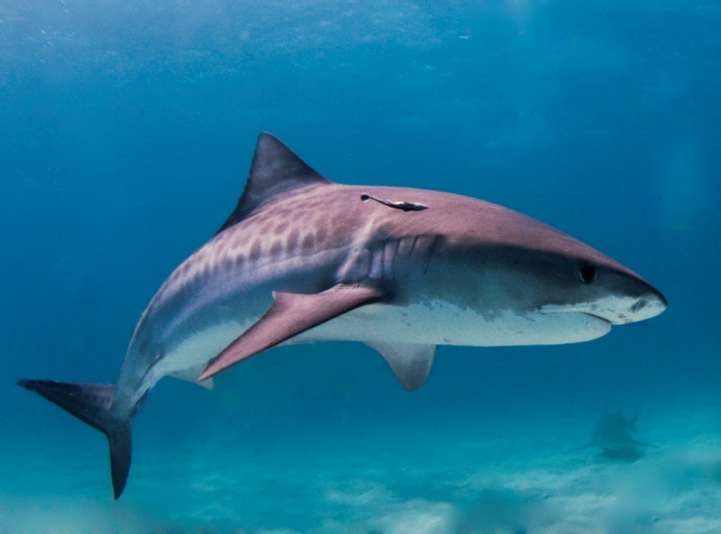
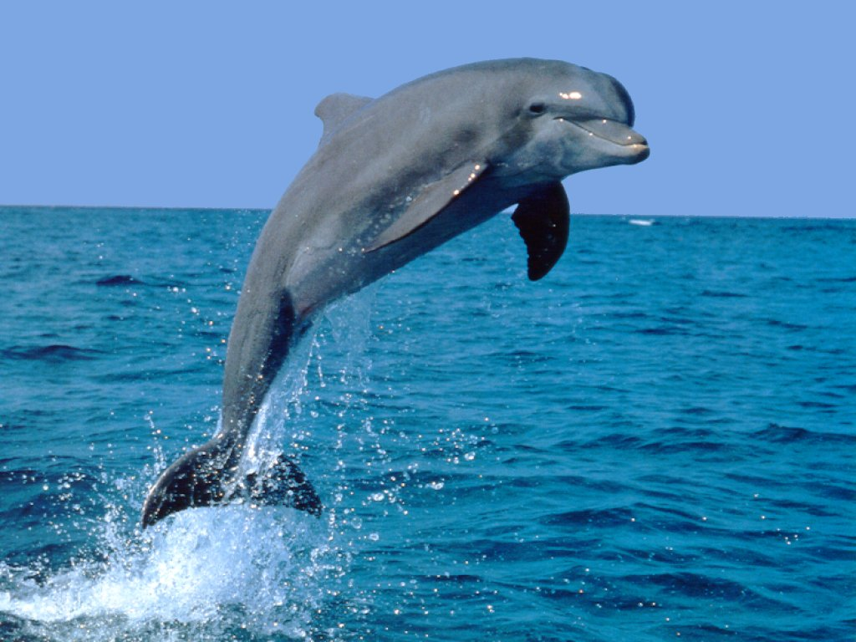

Annette adopted Norman, a blind yellow lab, from the pound. The beach is the only place he can run free because he is blind. One day, as Annette and Norman were walking along the beach, Norman cocked his ear and took off running. He heard something no one else could hear — the cries of someone in trouble. Lisa, 15, had been swimming with her brother and got caught in the current. Norman swam toward her cries, and with Annette’s voice guiding him, pulled Lisa back to shore. Lisa considers Norman her guardian angel.

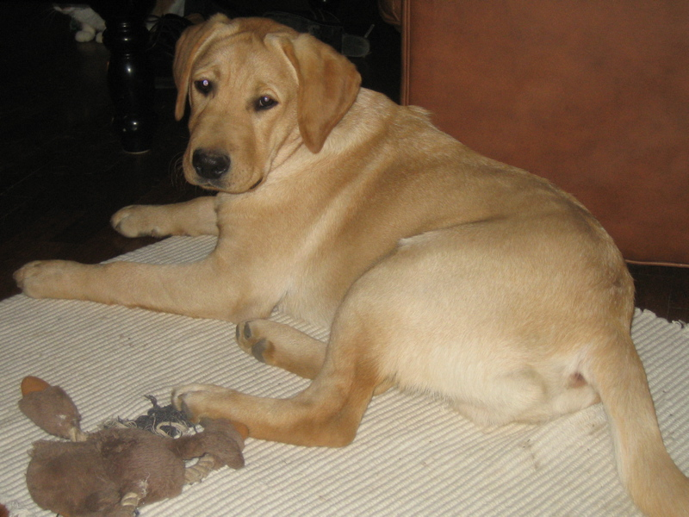

A chimp plays surrogate mom to a couple of tiger cubs—and somewhere, Walt Disney sees dollar signs. But Anjana, a 2 1/2-year-old chimp, just sees love. Every day, she can't wait to scoop up the 10-week-old cubs named Mitra and Shiva, kiss them, let them crawl all over her and then, after playtime has worn everyone down, feed them formula from a bottle. "When she first sees them she screams, gets goofy and lets out a laugh," says Dr. Bhagavan Antle, director of an animal sanctuary, the Institute of Greatly Endangered and Rare Species (TIGERS), in Myrtle Beach, S.C., where Anjana met the cubs. "Then she gets serious."
The improbable love story began in August when Hurricane Hanna cut a swath through the refuge. As rain and wind buffeted her shelter, Sukino, a white tiger, was suckling her two cubs. But the shelter was getting drenched and Antle reluctantly removed the fragile newborns, leaving the mother, and placed them in the care of one of his trainers, China York, in a drier, warmer building.
And that's where a beautiful friendship was born. Anjana "hangs out with me and watches what I'm doing," York, 27, says. So when the trainer began feeding the cubs, Anjana did the same. "You know, monkey see, monkey do," says York.
Anjana and the cubs have moved to a Miami park for the winter. The trio can't last forever—in a few months the cubs' bites will grow stronger and may provoke the powerful Anjana to unintentionally harm them; for now they're just happy to romp together. "It's really a joy to watch," says York.

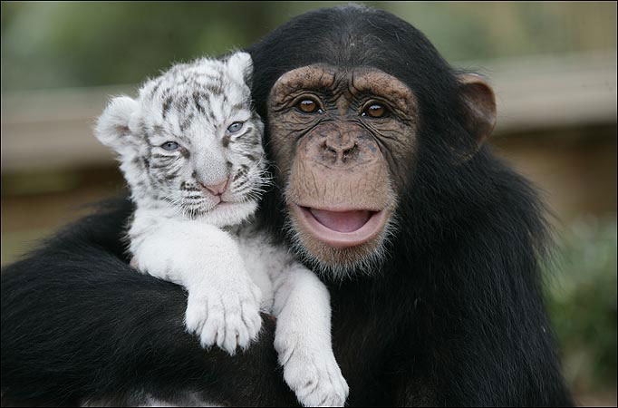

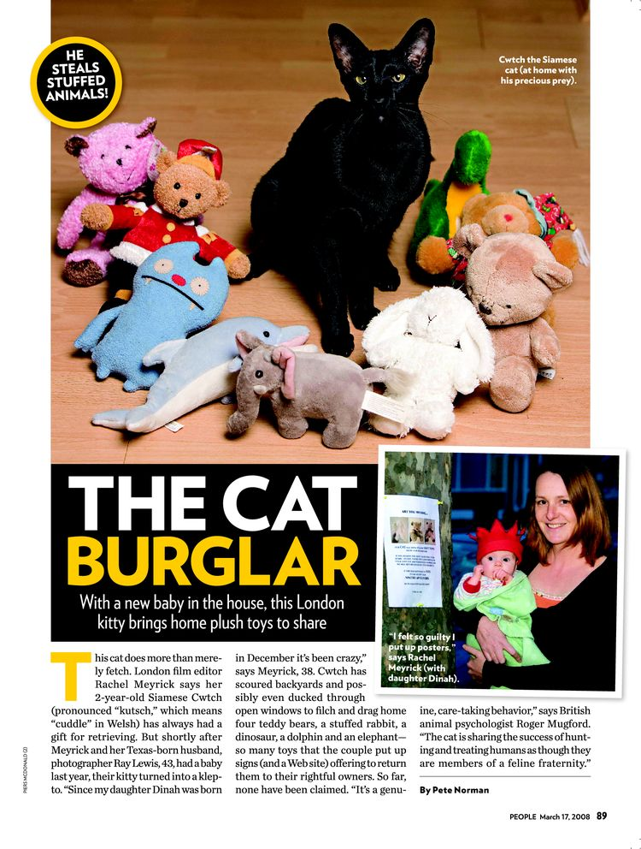

Take a gander at Andy the footless goose. That's what Gene Fleming did last fall when he stopped in to visit his sister-in-law Donna Mae Schuck's farm in Harvard, Nebr., and came across a sad sight. There was Andy, a 2-year-old gray goose born without feet, hobbling around Schuck's yard on his stumps. Fleming was moved by the plight of the unlucky but plucky fowl. "Because I'm a Shriner," he says, referring to the charitable organization whose mission is to aid crippled children, "my natural instinct, once I saw the goose, was to help him."
So Fleming gave his sister-in-law a more valuable pair of geese in exchange for Andy and Andy's lifetime mate, Polly. Back on his own 91-acre spread in nearby Hastings, the 66-year-old retired businessman and farmer fitted Andy with a pair of size 0 baby shoes. When the $13 white leather shoes lasted only a month, Fleming made the switch to sneakers. As for the steps he took to teach the 40-lb. bird a new way to walk, Fleming sounds like any proud papa. "I held Andy upright for three hours before he figured out what to do with those shoes," says Fleming. "But when he got the hang of them, he just took off. Now he struts around like a peacock."
Loose as a you-know-what, Andy also runs, swims, flies and shows affection for his goose Samaritan. "He knows what I did," says the crafty cobbler, "and I think he's grateful. He's a one-man goose."

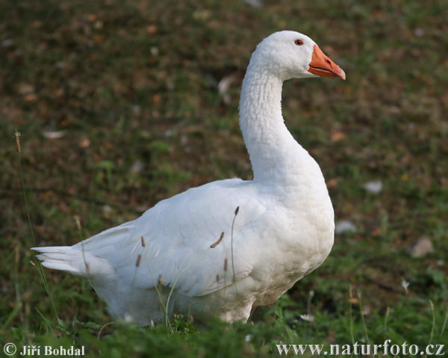

KUALA LUMPUR, Malaysia - A burglar who broke into a house claims he was held captive by a "supernatural figure" for three days without food and water, officials said.
Police official Abdul Marlik Hakim Johar told The Star newspaper the house's owners found the 36-year-old man fatigued and dehydrated when they returned from vacation Thursday.
He says they called an ambulance to take him to a hospital.

ig City: George Vera, who weighs nearly 600 pounds, was booked into jail in Houston in August and was in custody for more than 24 hours before he casually informed cops that they had missed finding the 9 mm handgun and two clips that were hidden in his rolls of fat. [KPRC-TV (Houston), 8-6-09]

This tortise had to have 3 of his appendages amputated so now they call him ‘wheelie’
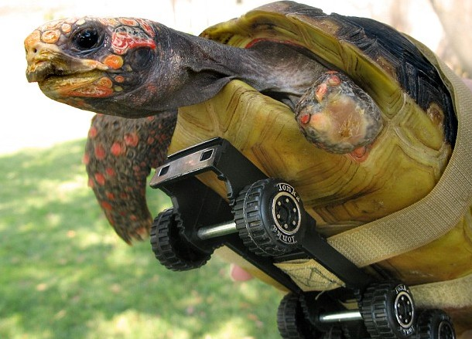

In June, in Ana Lee Spray's garage in Riverside County, Calif., a full-grown mountain lion was cornered and held at bay for 45 minutes by Spray's three Chihuahuas, yapping at it relentlessly. Eventually, animal control officers arrived and removed the grateful lion. [KTLA-TV (Los 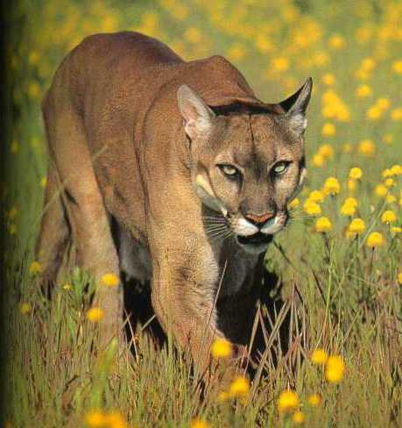

Police in South Africa are blaming a gang of at least 350 baboons for countless burglaries, thefts and vandalism in Cape Peninsula -- and they're not sure how to fight these hairy brutes.
There's one sign that you've been the victim of simian crime, and you're likely to step on it,
if you're not careful. "People here are getting very angry," Dr. Peter Kirsch told NBC News.
"They get into the kitchen. They know where the refrigerator is. They open it. They tear it to
pieces. They grab whatever food they can . . . and they defecate all over the place."
The colony blamed for the vandalism is the country's last colony of coastal baboons. They
are a protected species, so police are having a tough time figuring out a way to protect nervous
suburbanites, and still keep the animals safe. Police say they're not just breaking into homes.
They've become fascinated with cars.

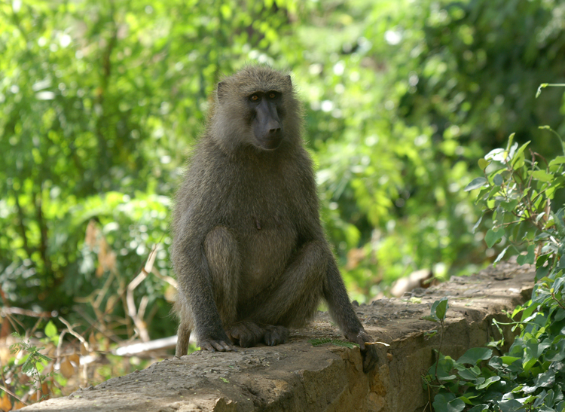

Terminally ill patients in a Colorado are getting an unexpected visitor: a 13-year-old llama pal.
Pisco’s monthly visits are part of an animal therapy program.

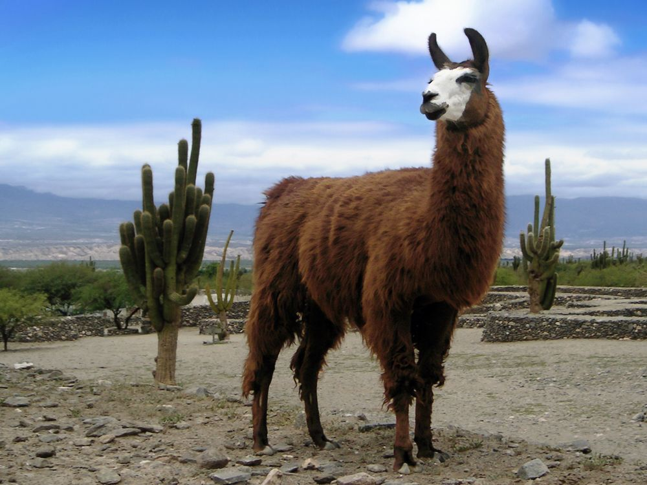

The zoo, in Bremerhaven, northern Germany, says the adult males - Z and Vielpunkt - were given an egg which was rejected by its biological parents. It says the couple are now happily rearing the chick, which has reached four weeks old. "Z and Vielpunkt, both males, gladly accepted their 'Easter present' and began straight away with hatching the egg," said a statement from the zoo."Since the chick arrived they are behaving in the same way as one would expect a heterosexual couple to do. Both happy fathers are now diligently handling the everyday care ... of their adopted offspring," the zoo said.Z and Vielpunkt are part of a six-strong gay community among the zoo's collection of endangered Humboldt penguins who rose to fame in 2005 when four Swedish females were brought in an unsuccessful, and controversial, attempt to "cure" them.Three pairs of male penguins had been seen attempting to mate with each other and trying to hatch offspring from stones."Homosexuality is nothing unusual among animals," the zoo said. "Sex and coupling up in our world do not necessarily have anything to do with reproduction."The Humboldt penguin is normally found on the coast of Chile and Peru, but numbers have dropped to between 12,000 and 20,000 as industrial fishing methods have led to dwindling stocks of the anchovies on which they feed.There have been previous reports of exclusive male-to-male pairings among penguins, some of which have also included the rearing of chicks.Other animals may simply exhibit a "drive to mate", while others may, like humans, enjoy non-procreative sexual activity.
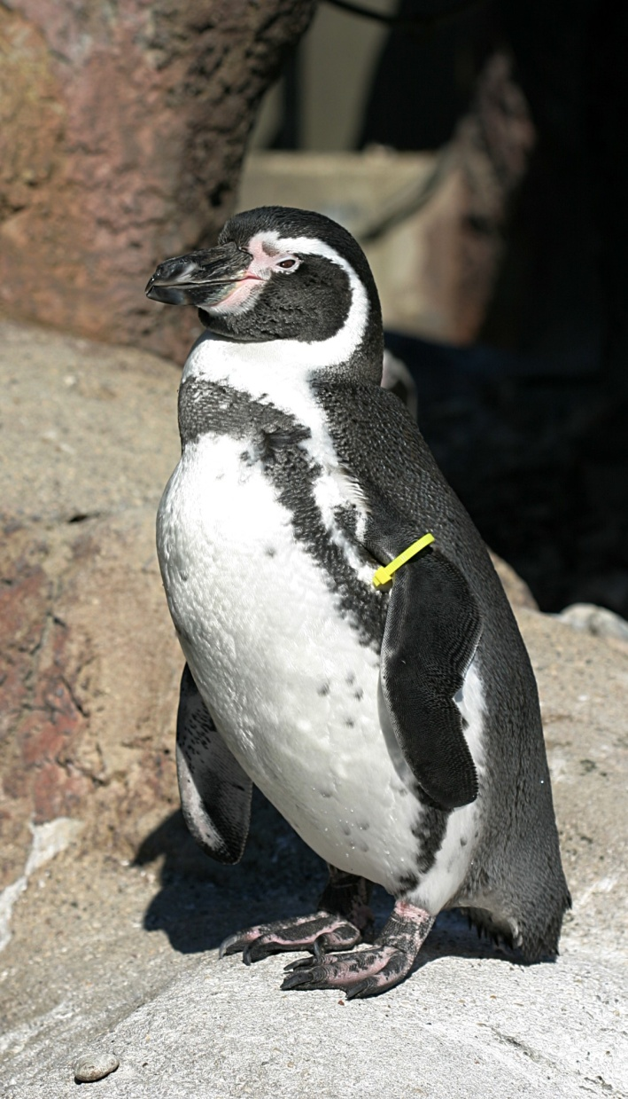

Politics is bugging the people of Aspen so much that a bug is now running for mayor, and
About.com's insect queen Debbie Hadley has the whole story.It seems that after 70
percent of city residents polled by the Aspen Times said they planned to vote for "Anybody
but Mick" -- a reference to incumbent Mick Ireland -- the door was left open to just about
anyone, and the people from this ski resort are famous for their political humor.Many of us
remember that Rolling Stone's famous gonzo journalist Hunter Thompson ran for county
sheriff in 1970 on a "Freak Power" ticket, promising to legalize drugs, tear up the streets
to plant more grass, and change the name of Aspen to "Fat City" to discourage real estate
developers and keep tourists away. Then, a lizard named "Sal A. Mander" ran for mayor,
sheriff and Colorado governor on the "Newtist" ticket. Sal, unfortunately has the unfortunate
problem of not being a "natural person," one of the criteria for running for office. The Red Ant
will undoubtedly face the same issue, leaving aside what her campaign managers call a
"fiery style." Paraphrasing Steven Colbert -- who ran his own joke campaign for president
last year -- the Red Ant said (through spokeswomen) that "I don't want to BE Mayor, I want
to RUN FOR Mayor. There's a difference." "If I have to prove it, so should Andrew and Mick,"
she said, in a swipe at Ireland and the other candidate, talk show host Andrew Kole.
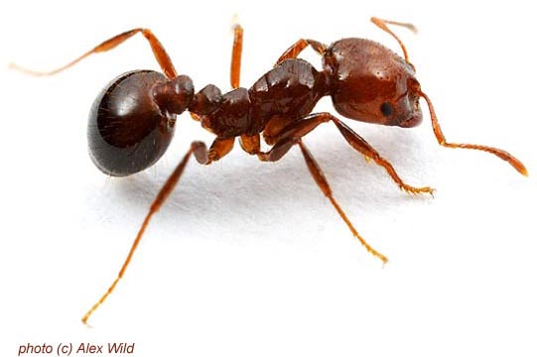

BRASILIA (Reuters) - Brazilian authorities detained a Portuguese man at Sao Paulo's international airport with 200 birds in his bag, police said on Thursday.
Customs officials found 65 of 200 Canary birds dead, the Agriculture Ministry said in a statement. Police will charge the man, who arrived from Peru and resides in Brazil, with animal trafficking, a federal police officer at the airport said.
The remaining live birds will be sent back to Peru by plane, in more humane conditions.

TOFO, Mozambique, Aug. 3 (UPI) -- A few enterprising Mozambicans say they might be able to turn their rabbit-sized, land mine-sniffing African rats into a tourist-attracting oddity.The rat handlers let their rodents poke around at the end of thin leashes until they scratch at the ground. That's the sign they've discovered an explosive device, The Georgia Straight reported in its section July 31. Dennis Adams, a hostel owner who moved to Mozambique from South Africa eight years ago, told the Vancouver, British Columbia, newspaper he thinks tourists could be attracted by the spectacle of giant rats looking for land mines.
"People would come and see the rats work in the field with the trainers," Adams said. "We could sell T-shirts, and the tourists could have their photos taken with them."
In fact, the rats are part of a non-profit Belgian group's efforts to remove thousands of land mines buried in Mozambique's soil during the country's bloody civil war, which ended in 1992.
If tourists don't like the rats, they can always head to the beaches for some scuba diving among the coral reefs, rife with manta rays and whale sharks, the newspaper noted.
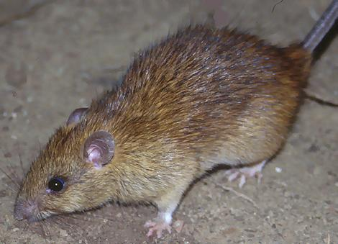

Fright of your life ... this 1.8m python was found in the toilet of a 10th floor apartment in Darwin. Snake catcher Chris Reberdy said he had to give it a good wash as "it was a bit on the smelly side".
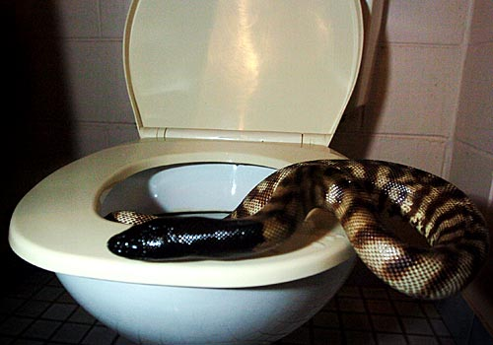

Dizzy ... this poor fella spent a week going round and round in a car's air-conditioning fan. The driver went to a mechanic because the car was making a strange noise.
